9th Friends of Industry Ministerial Conference
Warsaw, 26th October 2026

Practical information

Dear Delegations,
Please find below the practical information regarding the 9th Friends of Industry Ministerial Conference.

Venue
Warsaw Stock Exchange
4 Książęca Street
Warsaw
Please find below a map indicating the parking area and two entrances to the venue.
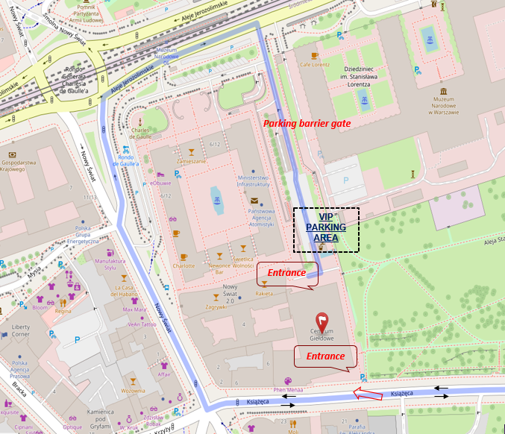

Schedule

The opening session will begin at 11:00 a.m. To ensure a smooth registration process, all delegations are kindly requested to arrive no later than 10:45 a.m.
The conference is expected to conclude at 3:30 p.m.
Please inform us by 16 October of the expected arrival time of your delegation.

Working language
The working language of the meeting will be English only.

Registration and security
For security and registration purposes, please provide us in advance with the following details for all participants:
- name and surname;
- position;
- licence plate information for cars wishing to enter and park on the premises of the Warsaw Stock Exchange;
- information on whether any participant will be carrying a firearm.
Please note that the format of the conference is 1+2.
We kindly ask you to provide all of the above information by 14 October.

Lunch
Please let us know the dietary preference of the head of delegation: meat-based or vegetarian meal. We also kindly ask you to inform us of any food allergies or intolerances of the head of delegation that should be taken into consideration.
Please provide this information by 16 October.

Bilateral meetings
Bilateral meetings may be arranged between 9:00 and 11:00 a.m. Dedicated rooms will be available for this purpose.
Should you wish to arrange any bilateral meetings, please let us know by 21 October, including Member States and suggested time of the meetings you would like to hold.

Contact
Please send all the requested information and any questions to:
friendsofindustry@mrit.gov.pl
We look forward to welcoming you and your delegation to Warsaw.
Kind regards,
The Friends of Industry Team

